SIMATS ENGINEERING
(SAVEETHA SCHOOL OF ENGINEERING)
Department of Computer Science and Engineering

CO2 ASSESSMENT TOOL 2
Architecture Design Assignment
Project Title:
Smart Food Supply Chain Traceability and Quality Monitoring System
Course Code | CSA10 | Course Title | Software Engineering
CO Assessed | CO2 | Assessment Tool | Assessment Tool 2 – Architecture Design
Weightage | 20% | Total Marks | 25

Student Name: _____________________________
Registration Number: _____________________________
Date: _____________________________
Duration: 60 minutes
Code of Conduct
I ______________________________ (Name / Reg. No.) certify that this submission is my original work and that I have adhered to the guidelines specified for this assessment. I understand that any violation of academic integrity rules will result in disciplinary action.
Signature of the Student: _________________________

Table of Contents
1. Introduction and Problem Statement Overview 3
2. System Requirements Analysis 4
3. Selection of a Suitable Software Architecture 7
4. Software Architecture Diagram 9
5. Components and Their Interactions 11
6. Discussion of Quality Attributes 14
7. Justification of Architectural Decisions and Trade-offs 16
8. Conclusion 18
References 18

1. Introduction and Problem Statement Overview
Food safety incidents, counterfeit produce labelling, and opaque cold-chain handling continue to erode consumer trust and cause significant economic loss across agricultural supply chains. A shipment of perishable goods typically passes through several independent actors — farmers, aggregators, cold-storage warehouses, third-party logistics providers, distributors, and retailers — each of which maintains its own fragmented records. When a contamination event or a temperature excursion occurs, the absence of a unified, verifiable, end-to-end record makes it extremely difficult to identify the affected batches quickly, resulting in large-scale recalls, wasted inventory, and prolonged health risk exposure.
The Smart Food Supply Chain Traceability and Quality Monitoring System is proposed to address this gap by digitizing every stage of the food journey — from farm harvest to consumer purchase — using a combination of Internet of Things (IoT) sensors, event-driven data pipelines, tamper-evident ledger storage, and consumer-facing verification tools. The system continuously captures environmental conditions (temperature, humidity, soil quality, and location), automatically validates them against food-safety thresholds, and links every batch to an immutable traceability record that can be verified by any authorized stakeholder in real time.
Problem Statement: Design a scalable, secure, and reliable software architecture for a system that enables real-time tracking of food products from origin to consumer, continuously monitors quality parameters during transportation and storage, and provides transparent, tamper-proof traceability information to producers, distributors, retailers, regulators, and end consumers.
This report performs a structured architecture design analysis for the proposed system in line with the CO2 Architecture Design Assignment requirements. It analyzes the functional and non-functional requirements that shape the system, evaluates candidate architectural styles, selects and justifies a hybrid architecture, presents a detailed architecture diagram, describes each component and its interactions, evaluates the design against the six core quality attributes, and concludes with a discussion of trade-offs and future extensibility.

2. System Requirements Analysis

2.1 System Objectives
Based on the problem statement, the Smart Food Supply Chain Traceability and Quality Monitoring System is expected to achieve the following core objectives:
- Provide end-to-end, batch-level traceability of food products from farm origin through processing, storage, transportation, and retail sale.
- Continuously monitor environmental and quality parameters (temperature, humidity, spoilage indicators) throughout the cold chain.
- Detect and alert stakeholders in real time when quality thresholds are breached or handling deviations occur.
- Give consumers a simple, verifiable way (e.g., QR code scan) to view the complete history and quality certification of a product.
- Support regulatory reporting, audit trails, and rapid, precisely-scoped recalls when safety issues are identified.
- Scale to accommodate a growing number of producers, distribution partners, sensor devices, and daily transactions without redesign.

2.2 Functional Requirements
The functional requirements below were derived directly from the problem statement and describe the observable behaviour the system must exhibit for its stakeholders — producers, distributors, retailers, regulators, and consumers.
ID | Requirement | Description
FR-01 | Batch Registration | Producers shall be able to register a new produce batch with origin, harvest date, and initial quality attributes.
FR-02 | Real-Time Sensor Ingestion | The system shall continuously ingest temperature, humidity, and location data from IoT sensors attached to storage units and transport vehicles.
FR-03 | Quality Threshold Validation | The system shall automatically compare incoming sensor readings against product-specific safety thresholds and flag violations.
FR-04 | Automated Alerting | The system shall notify relevant stakeholders (producer, distributor, retailer, regulator) within seconds of a detected threshold breach.
FR-05 | Immutable Traceability Ledger | The system shall record every custody transfer and quality event for a batch in a tamper-evident ledger.
FR-06 | Consumer Verification | Consumers shall be able to scan a QR/RFID code on a product to view its full traceability and quality history.
FR-07 | Role-Based Dashboards | The system shall provide differentiated dashboards for producers, distributors, retailers, and regulatory administrators.
FR-08 | Recall Management | The system shall allow administrators to identify and flag all affected batches and downstream shipments during a recall event.
FR-09 | Reporting & Analytics | The system shall generate historical and predictive analytics on spoilage trends, transit times, and compliance rates.
FR-10 | Third-Party Integration | The system shall integrate with external logistics, payment, and government compliance APIs.

2.3 Non-Functional Requirements
Non-functional requirements define the quality constraints the architecture must satisfy. These constraints are the primary drivers behind the architectural style selected in Section 3, since a food-safety system's value depends as much on how it behaves under load and failure as on the features it exposes.
ID | Attribute | Description
NFR-01 | Scalability | The system shall support horizontal scaling to accommodate a growing number of sensors, batches, and concurrent users without service degradation.
NFR-02 | Performance | Sensor event ingestion and threshold evaluation shall complete with a processing latency under 2 seconds under normal load.
NFR-03 | Reliability | Core traceability and alerting functions shall maintain correct behaviour even if individual services fail, using retries and message durability.
NFR-04 | Availability | Consumer-facing verification and quality-monitoring services shall maintain at least 99.9% uptime.
NFR-05 | Security | All data in transit and at rest shall be encrypted; access shall be governed by role-based authentication and authorization.
NFR-06 | Maintainability | Individual services shall be independently deployable and testable to minimize the impact of changes and simplify maintenance.
NFR-07 | Data Integrity | Traceability records shall be tamper-evident, ensuring that historical batch data cannot be silently altered.
NFR-08 | Interoperability | The system shall expose standard REST/event-based APIs to integrate with heterogeneous third-party and legacy systems.
NFR-09 | Usability | Consumer verification shall require no more than a single QR scan with no login or app installation.
NFR-10 | Portability | Edge and IoT components shall operate across a variety of hardware and network conditions, including intermittent rural connectivity.

2.4 Key Quality Attributes Influencing the Architecture
Six quality attributes were identified as having the greatest influence on architectural decisions for this system. Each is summarized below and is revisited in detail in Section 6 once the architecture has been presented.
Quality Attribute | Why It Matters for This System
Scalability | The number of producers, sensors, and shipment events grows continuously; the architecture must absorb this growth horizontally rather than requiring redesign.
Maintainability | Food-safety regulations and quality-monitoring rules evolve frequently, so individual capabilities must be modifiable in isolation.
Reliability | Undetected sensor failures or dropped events could mean an unsafe batch reaches consumers, so the design must tolerate partial failures gracefully.
Availability | Consumers and regulators may need to verify a batch at any time, including during peak retail hours, so critical services must remain accessible.
Performance | Cold-chain excursions must be detected and acted upon within seconds to prevent spoiled or unsafe produce from continuing downstream.
Security | Traceability data underpins legal compliance and consumer trust, so the system must protect against tampering, spoofing, and unauthorized access.

3. Selection of a Suitable Software Architecture

3.1 Architectural Styles Considered
Several established architectural styles were evaluated against the functional and non-functional requirements identified in Section 2. The comparison below highlights why no single traditional style, used in isolation, fully satisfies the demands of a continuously-sensing, multi-stakeholder food traceability platform.
Architectural Style | Strengths for This Problem | Limitations for This Problem
Layered Architecture | Simple to build and reason about; clean separation of presentation, logic and data. | Becomes a monolith at scale; a change to one module risks affecting the whole system; poor fit for independently scaling IoT ingestion versus reporting.
Client-Server | Straightforward request-response model; well understood. | Does not natively support the continuous, high-volume, asynchronous sensor streams generated by IoT devices.
Pure Microservices | Independent scaling and deployment of each capability; strong fault isolation. | On its own, still assumes synchronous request-driven communication and does not optimize for the always-on, high-frequency telemetry stream from sensors.
Event-Driven Architecture | Naturally suited to continuous IoT telemetry; decouples producers and consumers of data; supports real-time alerting. | Without service boundaries, event-driven logic alone can become difficult to organize, test and secure as functional scope grows.
Service-Oriented Architecture (SOA) | Encourages reusable, coarse-grained services and an enterprise service bus. | Heavier governance and integration overhead than needed for this system; ESBs can become a bottleneck for high-frequency sensor data.
Serverless | No infrastructure management; automatic scaling for bursty workloads. | Cold-start latency and vendor lock-in are less suitable for continuously streaming sensor ingestion and long-running blockchain consensus operations.

3.2 Selected Architecture: A Hybrid Layered – Microservices – Event-Driven Architecture
After evaluating the candidate styles, this report selects a hybrid architecture that combines three complementary styles into a single coherent design:
- Layered Architecture, used at the macro level to separate presentation (client apps), gateway/integration, application (microservices), messaging, and data persistence concerns.
- Microservices Architecture, used within the application layer so that Traceability, Quality Monitoring, Inventory, Notification, Auth, and Analytics capabilities can each be developed, deployed, and scaled independently.
- Event-Driven Architecture, used to connect IoT devices and microservices through an asynchronous Event Bus (Kafka/MQTT), which is essential for handling continuous, high-volume sensor telemetry without blocking producers or consumers.
This combination allows the system to benefit from the clarity of layered separation, the independent scalability and fault isolation of microservices, and the responsiveness and loose coupling of event-driven messaging — each addressing a distinct set of requirements that no single style could satisfy alone.

3.3 Justification for the Selected Architecture
Alignment with IoT-driven data volume: The food supply chain continuously generates high-frequency sensor telemetry from thousands of distributed devices. An event-driven backbone (Kafka/MQTT) allows this data to be ingested asynchronously without forcing producers (sensors, edge gateways) to wait on downstream processing, satisfying NFR-02 (Performance) and NFR-01 (Scalability).
Independent scalability of hot paths: Quality Monitoring and Traceability services experience far higher request volume than, say, Analytics or Admin services. Microservices allow each capability to be scaled independently based on its own load profile, rather than scaling an entire monolith to satisfy the busiest module.
Fault isolation for safety-critical functions: If the Analytics service fails, alerting and traceability must continue to operate. Microservices combined with an asynchronous event bus ensure that a failure in one bounded context does not cascade into safety-critical functions, satisfying NFR-03 (Reliability) and NFR-04 (Availability).
Support for heterogeneous stakeholders: A layered presentation tier cleanly supports multiple client types — consumer mobile app, retailer dashboard, producer portal, and admin console — behind a single API Gateway, simplifying authentication, rate-limiting and versioning.
Extensibility and maintainability: New capabilities (for example, a carbon-footprint calculator or a new regulatory-compliance module) can be added as new microservices that subscribe to existing events on the bus, with minimal impact on existing services, satisfying NFR-06 (Maintainability).
Data integrity by design: Placing an immutable/blockchain-backed traceability ledger within the data layer, fed via validated events, provides tamper-evident record-keeping that directly satisfies NFR-07 (Data Integrity) without requiring every service to implement its own integrity controls.

4. Software Architecture Diagram

4.1 Overall Architecture Diagram
Figure 1 presents the complete hybrid architecture of the Smart Food Supply Chain Traceability and Quality Monitoring System. The diagram is organized as seven horizontal layers, from client-facing presentation components at the top down to external third-party integrations at the bottom, with the Event Bus acting as the central nervous system connecting the microservices layer to the IoT/edge device layer.
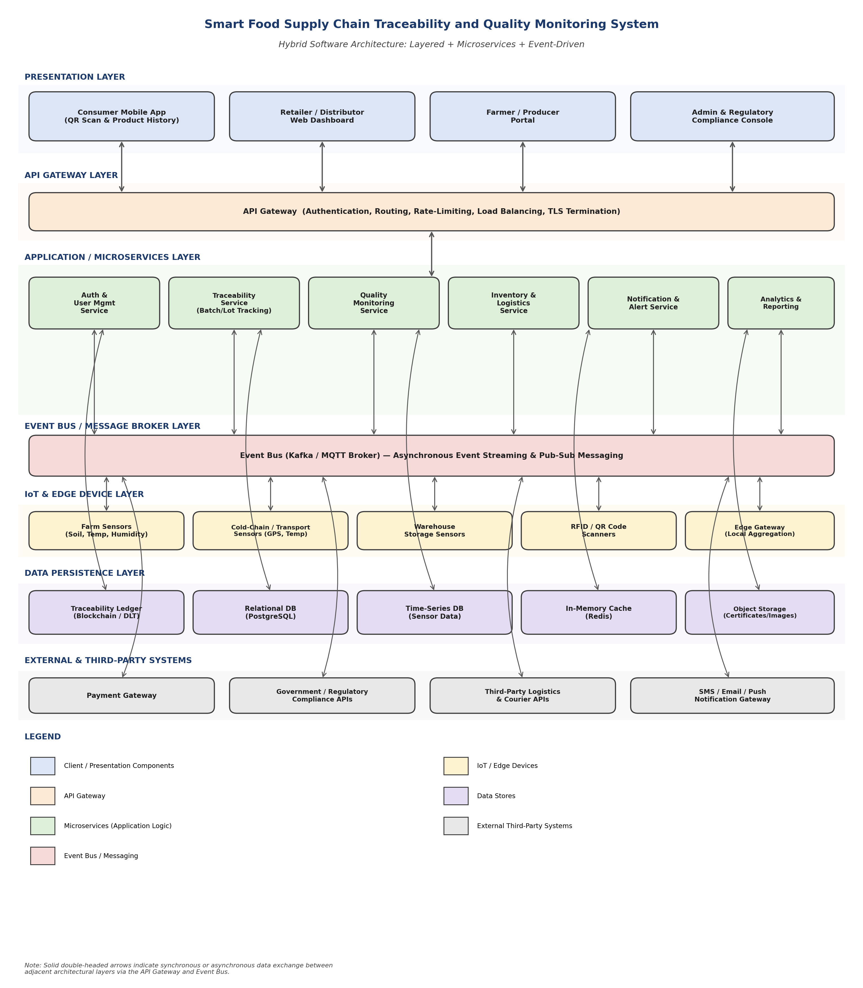
Figure 1: Hybrid (Layered + Microservices + Event-Driven) Architecture of the Smart Food Supply Chain Traceability and Quality Monitoring System

4.2 Layer-by-Layer Notation and Description
Each layer in Figure 1 is colour-coded and labelled according to the legend shown in the diagram. Table 4 summarizes the purpose of each layer and lists its major constituent components.
Layer | Major Components | Purpose
Presentation Layer | Consumer Mobile App, Retailer/Distributor Web Dashboard, Farmer/Producer Portal, Admin & Regulatory Console | Provide role-specific interfaces for every stakeholder to interact with the platform.
API Gateway Layer | API Gateway | Single entry point performing authentication, request routing, rate-limiting, load balancing and TLS termination for all client traffic.
Application / Microservices Layer | Auth & User Management, Traceability, Quality Monitoring, Inventory & Logistics, Notification & Alert, Analytics & Reporting services | Encapsulate the core business logic of the system as independently deployable services.
Event Bus / Message Broker Layer | Kafka / MQTT Broker | Decouples producers (sensors, services) from consumers (services, alerting) via asynchronous publish-subscribe messaging.
IoT & Edge Device Layer | Farm sensors, cold-chain/transport sensors, warehouse sensors, RFID/QR scanners, edge gateway | Capture real-world environmental and location data and perform local aggregation before publishing to the Event Bus.
Data Persistence Layer | Traceability Ledger (Blockchain/DLT), Relational DB, Time-Series DB, Cache, Object Storage | Persist transactional, time-series, and tamper-evident traceability data using the storage engine best suited to each data shape.
External & Third-Party Systems | Payment Gateway, Regulatory Compliance APIs, Logistics/Courier APIs, Notification Gateway (SMS/Email/Push) | Integrate the platform with services outside the organizational boundary that are required to complete business workflows.
Double-headed arrows in the diagram represent bidirectional data exchange — synchronous request/response through the API Gateway for client-facing interactions, and asynchronous publish/subscribe messaging through the Event Bus for sensor telemetry and inter-service events. This notation makes explicit which parts of the system are designed for immediate response and which are designed for eventually-consistent, high-throughput processing.

5. Components and Their Interactions

5.1 Component Responsibilities
Table 5 describes the purpose of each major architectural component identified in Figure 1 and summarizes how it communicates with the rest of the system.
Component | Responsibility | Interaction / Communication
API Gateway | Single entry point for all client requests; authenticates callers, enforces rate limits, and routes traffic to the correct microservice. | Communicates synchronously (REST/HTTPS) with client applications and with backend microservices.
Auth & User Management Service | Manages stakeholder identities, roles (producer, distributor, retailer, regulator, consumer, admin) and issues access tokens. | Called synchronously by the API Gateway on every authenticated request; publishes user lifecycle events to the Event Bus.
Traceability Service | Maintains the batch/lot lifecycle — registration, custody transfers, and linkage to quality events; assembles the full history returned on a consumer QR scan. | Consumes custody and quality events from the Event Bus; writes to the Traceability Ledger and Relational DB; responds synchronously to gateway-routed lookup requests.
Quality Monitoring Service | Evaluates incoming sensor telemetry against product-specific safety thresholds and raises quality events on violations. | Consumes raw sensor events from the Event Bus; publishes quality-violation events back onto the bus; queries the Time-Series DB for trend analysis.
Inventory & Logistics Service | Tracks stock levels, shipment status, and coordinates with external logistics/courier APIs. | Publishes and consumes shipment-status events; calls third-party logistics APIs synchronously.
Notification & Alert Service | Delivers real-time alerts to the appropriate stakeholders when a quality or custody exception occurs. | Subscribes to alert-worthy events on the bus; invokes the external SMS/Email/Push notification gateway.
Analytics & Reporting Service | Aggregates historical data to surface spoilage trends, transit-time statistics, and compliance dashboards. | Consumes events asynchronously (non-blocking) and reads from the Time-Series and Relational DBs; never sits on the critical alerting path.
Event Bus (Kafka/MQTT) | Central asynchronous messaging backbone that decouples all event producers from all event consumers. | Receives events from IoT devices and microservices; delivers them to all subscribed services with durable, replayable storage.
Edge Gateway | Aggregates readings from nearby sensors locally, performs basic validation/compression, and forwards batched events to the Event Bus over intermittent networks. | Publishes to the Event Bus over MQTT; buffers events locally during connectivity loss and replays them once reconnected.
Traceability Ledger (Blockchain/DLT) | Stores an append-only, cryptographically-linked record of custody transfers and quality certifications for each batch. | Written to by the Traceability Service after validation; read by services and, indirectly, by consumers verifying a batch.

5.2 Communication Mechanisms
The architecture deliberately mixes synchronous and asynchronous communication patterns, applying each where it is best suited rather than defaulting to one mechanism throughout the system.
Interaction | Mechanism | Rationale
Client ↔ API Gateway | Synchronous REST over HTTPS | Request/response for dashboards, lookups, and administrative actions where the user is waiting for an immediate result.
API Gateway ↔ Microservices | Synchronous REST / gRPC (internal network) | Routes authenticated, rate-limited requests to the responsible microservice and returns its response to the client.
IoT/Edge ↔ Event Bus | Asynchronous Pub/Sub over MQTT | High-frequency, lightweight telemetry publishing suited to constrained IoT devices and variable network conditions.
Microservices ↔ Event Bus | Asynchronous Pub/Sub (Kafka topics) | Services publish domain events (e.g., BatchRegistered, ThresholdBreached) and subscribe to events relevant to their bounded context.
Microservices ↔ Data Stores | Direct, service-owned database access | Each service owns its schema/store to preserve loose coupling; no service directly queries another service's database.
Microservices ↔ External Systems | Synchronous/asynchronous REST & webhook callbacks | Integrates payment, regulatory, logistics, and notification providers without embedding third-party logic inside core services.

5.3 End-to-End Workflow: Farm-to-Consumer Data Flow
Figure 2 illustrates how data flows through the architecture for a single produce batch, from initial harvest registration through to final consumer verification, and highlights the cross-cutting concerns — authentication, encryption, logging, and monitoring — that apply at every stage.
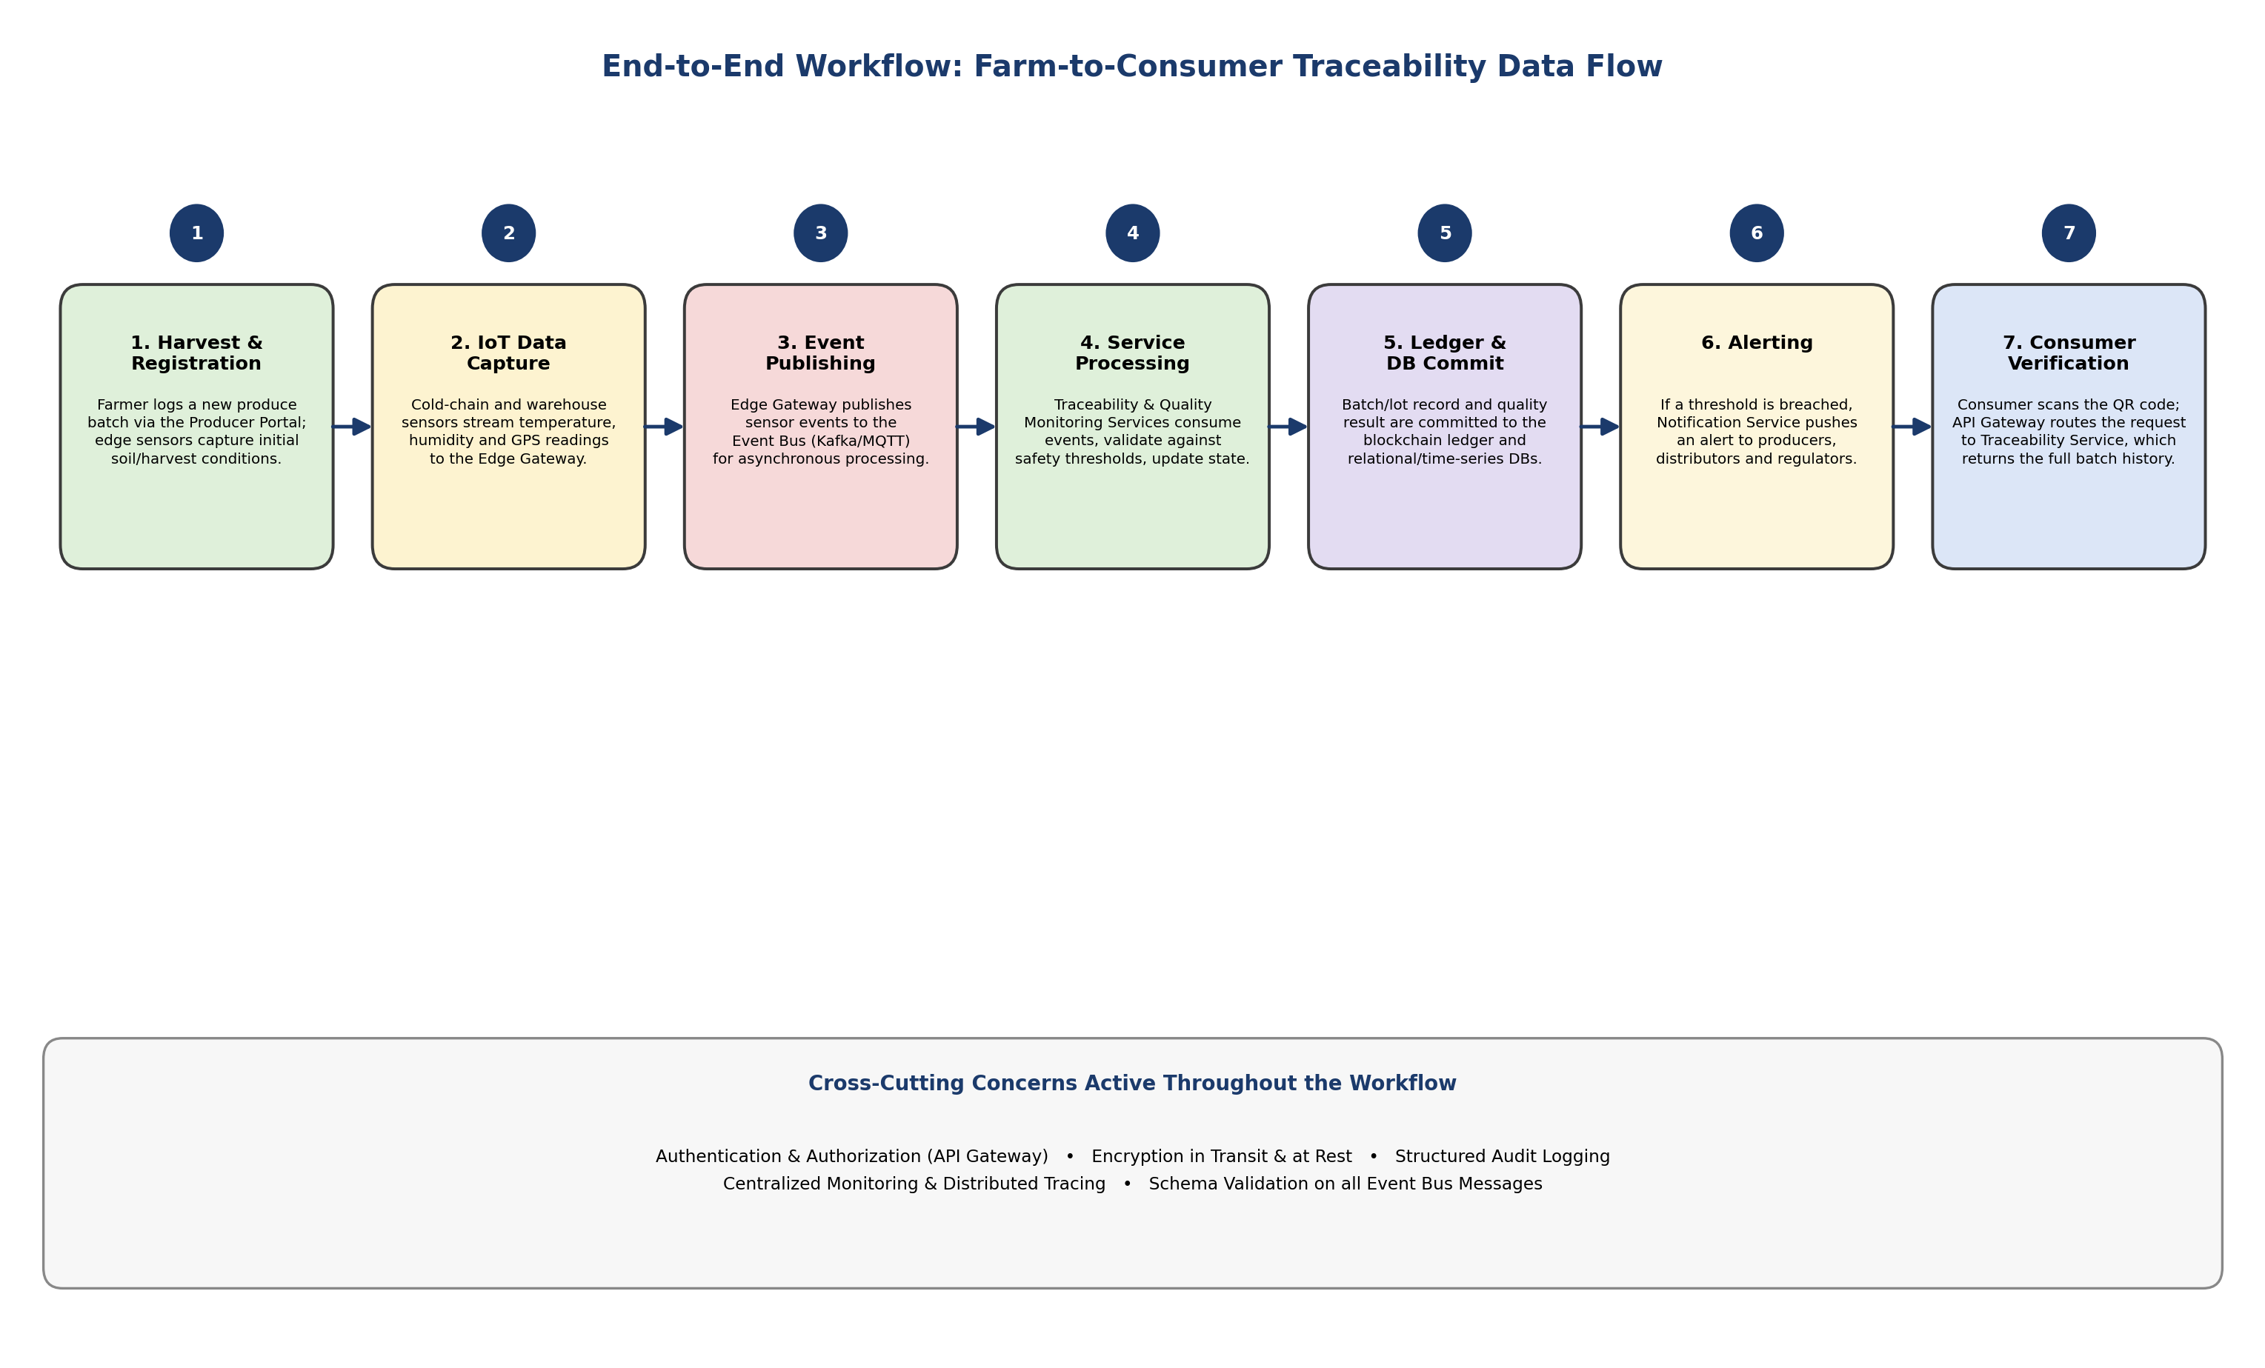
Figure 2: End-to-End Farm-to-Consumer Traceability Workflow
As shown in Figure 2, the workflow begins when a farmer registers a new batch through the Producer Portal (Step 1). As the batch moves through cold storage and transport, IoT sensors continuously capture environmental readings (Step 2) and publish them as events onto the Event Bus (Step 3). The Quality Monitoring and Traceability services independently consume these events, validate them against safety thresholds, and update the batch's state (Step 4). Validated records are committed to both the blockchain-backed traceability ledger and the relational/time-series databases (Step 5). If any threshold is breached at any point, the Notification Service immediately alerts the relevant stakeholders (Step 6). Finally, when a consumer scans the product's QR code at the point of sale, the request passes through the API Gateway to the Traceability Service, which assembles and returns the batch's complete, verifiable history (Step 7).

6. Discussion of Quality Attributes
This section evaluates how the selected hybrid architecture satisfies the six quality attributes identified as most critical in Section 2.4, referencing specific structural decisions made in Sections 3 through 5.

6.1 Scalability
Each microservice can be scaled independently based on its own demand profile — for example, the Quality Monitoring Service can be scaled out horizontally during peak harvest season without over-provisioning the Analytics service. The Event Bus further decouples producers from consumers, so a sudden surge in sensor telemetry is absorbed as durable, partitioned message logs rather than overwhelming any single service. Kafka's partitioning model allows sensor topics to be scaled by adding partitions and consumer instances as the number of connected devices grows, giving the system near-linear horizontal scalability.

6.2 Security
Security is layered throughout the architecture rather than relying on a single control point. The API Gateway centralizes authentication and authorization using role-based access control, so every client request is verified before it reaches a microservice. All communication channels use TLS in transit, and sensitive data (personally identifiable information, payment details) is encrypted at rest. The blockchain-backed traceability ledger provides an additional, structural security guarantee: once a custody or quality event is committed, it cannot be silently altered, which protects against both malicious tampering and accidental data corruption.

6.3 Performance
Performance-critical paths — sensor ingestion and threshold evaluation — are handled asynchronously through the Event Bus, which avoids blocking edge devices or downstream services while data is processed. The Time-Series database is purpose-built for high-write-throughput sensor data, and an in-memory cache (Redis) is used to serve frequently-accessed traceability lookups (for example, a popular product's certification) without repeatedly querying the primary data stores. Together, these decisions target the sub-2-second processing latency defined in NFR-02.

6.4 Reliability
Reliability is achieved primarily through decoupling and message durability. Because services communicate through a durable Event Bus rather than direct synchronous calls, a temporary outage in one microservice does not cause cascading failures elsewhere — events simply queue until the affected service recovers and resumes processing. Edge gateways buffer sensor readings locally during network interruptions and replay them once connectivity is restored, ensuring no data is silently lost even in rural or low-connectivity regions.

6.5 Maintainability
The microservices decomposition means each service has a single, well-defined responsibility (Traceability, Quality Monitoring, Notification, and so on), can be developed by a small independent team, and can be updated, tested, and redeployed without requiring a full-system release. New regulatory rules or quality thresholds can typically be implemented as a change confined to the Quality Monitoring Service, minimizing regression risk across the rest of the platform. Well-defined event schemas on the Event Bus act as stable contracts between services, further isolating the impact of internal implementation changes.

6.6 Availability
Consumer-facing verification and safety-critical alerting are designed to remain available even under partial system failure. Because the Analytics and Reporting service sits off the critical path (it only consumes events asynchronously), its failure or slow performance has no impact on the availability of traceability lookups or alerting. Running multiple instances of the Traceability and Notification services behind the API Gateway, combined with the durability of the Event Bus, supports the 99.9% availability target defined in NFR-04 for these safety-critical functions.

7. Justification of Architectural Decisions and Trade-offs

7.1 Rationale Behind the Architectural Choices
The architectural decisions made throughout this report were driven directly by the nature of the problem: a continuously-sensing, safety-critical, multi-stakeholder supply chain cannot be adequately served by a single traditional architectural style. Choosing a layered organization at the macro level keeps the overall system easy to reason about; decomposing the application layer into microservices ensures that the components with the highest load and highest change-frequency (Traceability and Quality Monitoring) can evolve and scale independently of lower-priority components (Analytics, Admin); and introducing an event-driven backbone directly matches the always-on, high-volume nature of IoT sensor data. Every major requirement identified in Section 2 can be traced to a specific structural decision in Sections 3 through 5, which demonstrates that the architecture is not merely fashionable but is a deliberate response to the stated problem.

7.2 Trade-offs Considered
No architecture is free of trade-offs. Table 6 documents the principal trade-offs weighed during the design process and the rationale for the choice made in each case.
Trade-off | Cost | Justification for the Choice Made
Operational complexity vs. flexibility | A microservices-plus-event-bus design requires more operational tooling (service discovery, monitoring, message broker administration) than a monolith. | The independent scalability, fault isolation, and team autonomy gained are essential for a system that must evolve continuously alongside changing food-safety regulations.
Eventual consistency vs. strong consistency | Asynchronous event processing means there can be a brief delay between a sensor reading and its reflection in the traceability record. | Given that safety-critical alerts are still delivered within seconds, this small delay is an acceptable trade-off for the scalability and resilience gained; strongly consistent synchronous calls would create tight coupling and bottlenecks.
Blockchain overhead vs. tamper-evidence | Writing every custody/quality event to a distributed ledger adds latency and storage overhead compared to a plain relational database. | The tamper-evidence guarantee is central to consumer trust and regulatory compliance, so the additional overhead is justified and is isolated to the Traceability Service rather than affecting the whole system.
Polyglot persistence vs. simplicity | Using four different data stores (ledger, relational, time-series, cache) increases the operational surface area compared to a single database. | Each store is matched to the access pattern it serves best (immutable records, transactional data, high-frequency writes, low-latency reads), which materially improves performance and scalability.
Initial development cost vs. long-term agility | The hybrid architecture requires more upfront design and infrastructure investment than a simple layered monolith. | The investment pays off as the platform scales to more producers, sensors, and regulatory jurisdictions, since new capabilities can be added as independent services rather than through disruptive rewrites.

7.3 Support for Future Enhancements, Integration, and Long-Term Maintainability
The hybrid architecture was deliberately designed to accommodate growth without structural rework:
- New sensor types (e.g., gas-composition or ethylene sensors for ripeness detection) can be onboarded by publishing to a new Event Bus topic, with no change required to existing services.
- New stakeholder-facing capabilities, such as a carbon-footprint calculator or a sustainability-scoring dashboard, can be added as new microservices that subscribe to existing traceability and quality events.
- Additional regulatory jurisdictions can be supported by extending the Quality Monitoring Service's rule set or by adding a jurisdiction-specific compliance microservice, without touching the core traceability pipeline.
- Third-party integrations (new logistics partners, alternative payment processors, additional notification channels) are isolated behind well-defined external-system adapters, so integration changes do not ripple into core business logic.
- Because each microservice owns its own datastore and communicates only through documented events and APIs, individual services can be re-implemented, migrated to new technology, or independently scaled over time without impacting the rest of the platform — directly supporting NFR-06 (Maintainability) over the system's multi-year lifecycle.

8. Conclusion
This report analyzed the requirements of the Smart Food Supply Chain Traceability and Quality Monitoring System and designed a hybrid Layered – Microservices – Event-Driven architecture to satisfy them. The layered organization gives the system a clear, understandable structure; the microservices decomposition allows the highest-demand capabilities to scale and evolve independently; and the event-driven backbone provides the responsiveness and loose coupling required to process continuous, high-volume IoT telemetry from a geographically distributed set of farms, warehouses, and transport vehicles.
The architecture was evaluated against the six core quality attributes — scalability, security, performance, reliability, maintainability, and availability — and shown to address each through specific, traceable design decisions rather than generic assertions. While the design introduces additional operational complexity compared to a simple monolithic system, this cost is justified by the fault isolation, independent scalability, and long-term extensibility that a continuously-evolving, safety-critical, multi-stakeholder platform requires. Overall, the proposed architecture provides a solid, extensible foundation capable of supporting the Smart Food Supply Chain Traceability and Quality Monitoring System from initial deployment through long-term growth.

References
[1] Newman, S. Building Microservices: Designing Fine-Grained Systems. O'Reilly Media.
[2] Richardson, C. Microservices Patterns: With Examples in Java. Manning Publications.
[3] Kleppmann, M. Designing Data-Intensive Applications. O'Reilly Media.
[4] Apache Kafka Documentation — https://kafka.apache.org/documentation/
[5] MQTT.org — MQTT Protocol Specification — https://mqtt.org/
[6] Bass, L., Clements, P., Kazman, R. Software Architecture in Practice. Addison-Wesley.
[7] Fowler, M. “What do you mean by ‘Event-Driven’?” martinfowler.com.

